Dress Code:
Male or those identifying as such.

Tailored smart trousers or chinos
A collared shirt (ties optional)
Smart no-logo polo (summer)
Smart blazers are optional
Leather look or suede shoes/ankle boots
Jumpers may be worn in the study area, or under blazers/jackets around school
Hair style appropriate for a place of business
Lanyards must be worn at all times whilst on site




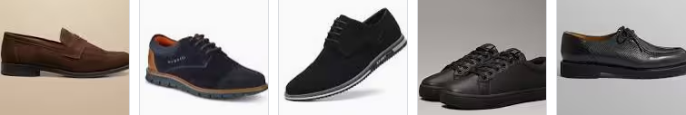

Female or those identifying as such.

Tailored skirts/dresses of an appropriate length at the knee.
Tailored smart trousers or chinos
Smart blazers are optional
Blouse, shirt or smart top
Hair style appropriate for a place of business
Smart jumpers, cardigans and blazers all permitted
Dark coloured polishable, leather look or suede shoes/ankle boots
Lanyards must be worn at all times whilst onsite




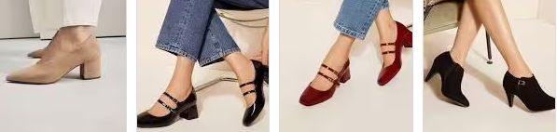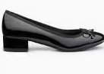

Expectations

Coats should not be worn in the school building.
Hats, winter scarves or gloves should not be worn during registration, in lessons inside the school buildings.
No denim jackets
No black jeans or leggings
No hoodies (including when worn as a coat or extra layer)
1 discrete nose piercing and no additional facial piercings
No extreme hairstyles and colours (natural hair colours only)
No tattoos
No Sheer, low-cut tops, crop tops, off the shoulder tops or tops with thin straps
No leggings or jeggings
No over-sized brand names, slogans or logos

Sportswear

Students studying sports courses or following the basketball programme must have the correct sports uniform. This is to be worn when training only. At all other times business wear must be worn. Students must change and exercise good hygiene when moving between training and studying. Students taking part in sports courses and training must wear appropriate sports kit.

We reserve the right to ask students to modify/ change their dress if they do not meet the aims or requirements of the Sixth Form dress code. Sixth Form students inappropriately dressed will be asked to return home to change. Students will not attend lessons, or communal areas if they are not in the correct attire. This will affect lesson attendance and therefore possibly progress.

Please contact the Director of Sixth Form, atombs@hartlandhigh.co.uk for any questions.

